**Assignment12-2**

**Given a list of strings - List[String] (“alpha”, “gamma”, “omega”, “zeta”, “beta”)**

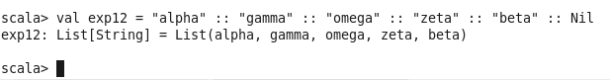

**1.find count of all strings with length 4**

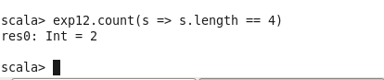

**2.convert the list of string to a list of integers, where each string is mapped to its corresponding length**

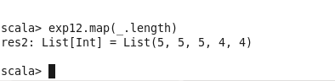

**3.find count of all strings which contain alphabet ‘m’**



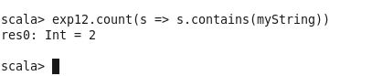

**4.find the count of all strings which start with the alphabet ‘a’**

